**Lab – 41: How to add apps to Microsoft Intune through AppStore URL & assign it to the group?**

**Objective:** The objective of this lab is –

* To add an app through AppStore URL to Microsoft Intune.

In this lab, we are going to add VLC Media Player app through AppStore URL and will assign it to the test group that we have already created.

**Prerequisite:** EMS Enterprise Mobility + Security E5.

**Steps:**

1. Sign in to your Azure Portal, by using the link - **https://portal.azure.com/**. Enter your credentials and click Sign In.

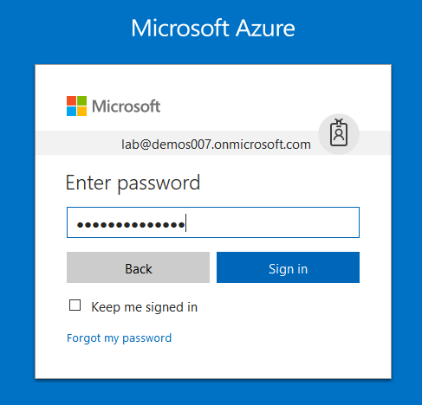

1. Microsoft Azure AD Dashboard will open.

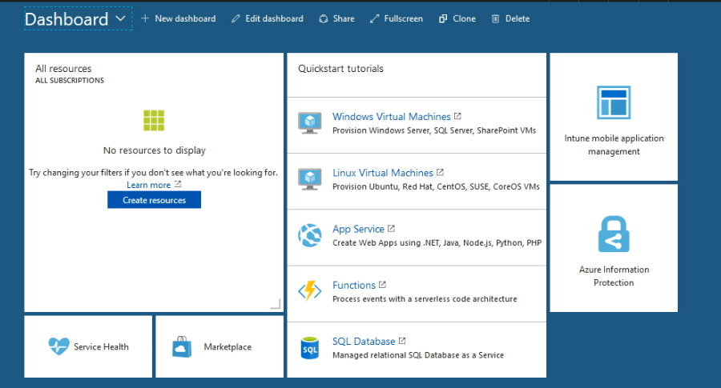

1. Open **Microsoft Intune** service from the left-hand side of the Azure portal.
2. Once you've opened the **Microsoft Intune** blade, select **Overview**.

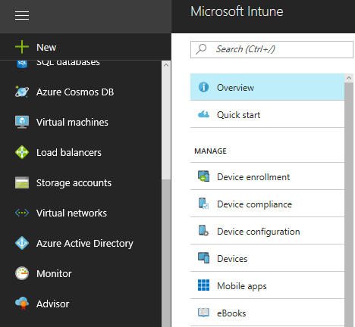

1. Then select **Add an App** from Quick tasks at the right hand side.

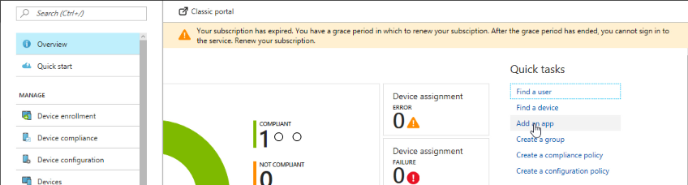

1. In the **Mobile apps** workload, choose **Manage** > **Apps**.

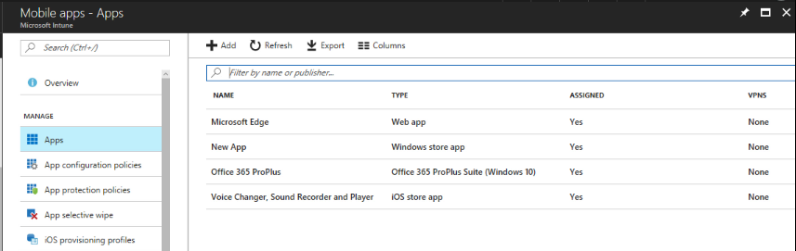

1. Above the list of apps, choose **Add**.

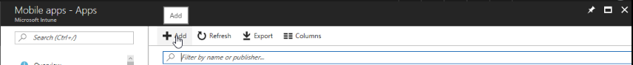

1. In the **Add App** blade choose the **App type**.

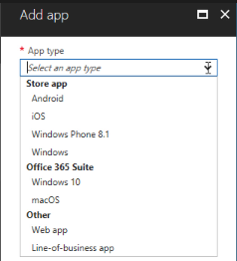

1. In the **Add App** blade, choose **App Information**.

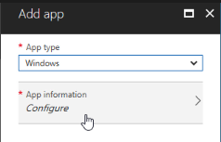

1. Then in the App information blade, configure the information:

App Name: Enter the name of the app as it will be displayed in the company portal.

Description: Enter a description for the app. This will be displayed to end users in the company portal.

Publisher: Enter the name of the publisher of this app.

AppStore URL: To enter AppStore URL, go to Microsoft.com/en-in/store/apps/windows, open the app that you want to add, here VLC, then copy the AppStore URL and paste it in the App Information blade.

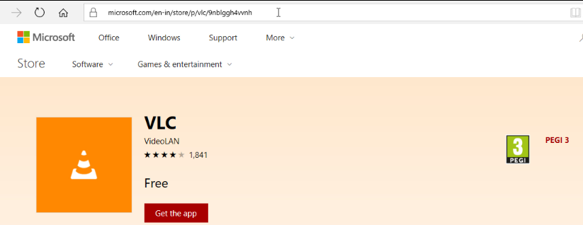

Category (optional) - Select one or more of the built-in app categories, or a category you created. This will make it easier for users to find the app when they browse the company portal.

Display this as a featured app in the Company Portal - Display the app prominently on the main page of the company portal when users browse for apps. For this select **Yes**.

Information URL – Add information URL, you can copy the same URL as you copied in the AppStore URL.

Privacy URL – Add privacy URL for your users.

Also you can add Developer, Owner and Notes.

Upload Icon - Upload an icon that will be associated with the app. This is the icon that will be displayed with the app when users browse the company portal.

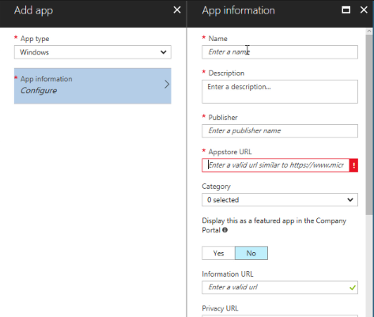

1. After configuring click **OK** in the App information blade.
2. When you are done, on the Add App blade, choose **Add**. It will add application and also you will get the notification at the top right corner.

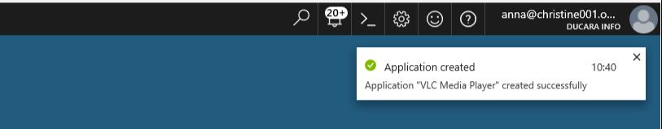

1. The app you have created will be displayed in the apps list where you can assign it to the groups you choose.
2. On the <app name> - **Overview** blade, choose **Manage** > **Assignments**.

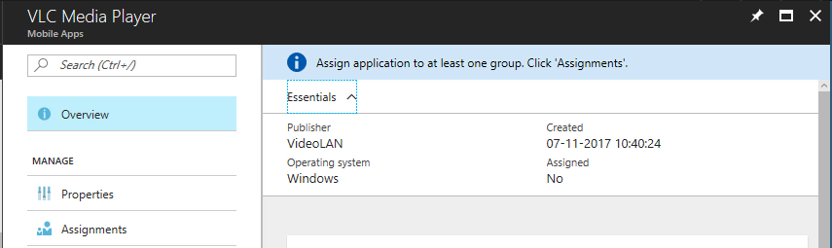

1. Choose **Select Groups** then.

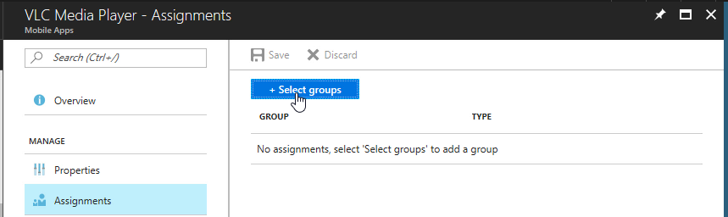

1. Then, on the **Select groups** blade, choose the Azure AD groups to which you want to assign the app and click **Select**.

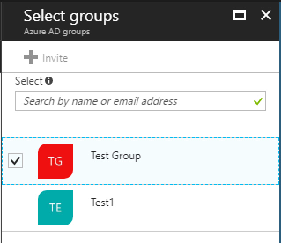

1. For each app you choose, choose an **assignment type** for the app from.

Available - Users install the app from the Company Portal app or website.

Not Applicable - The app is not installed or shown in the Company Portal.

Available with or without enrollment - Assign this app to groups of users whose devices are not enrolled with Intune.

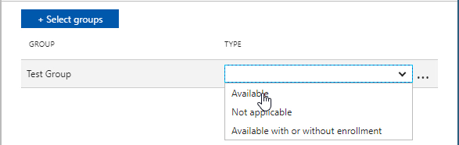

1. Once you are done, choose **Save**. The app is now assigned to the groups you selected.

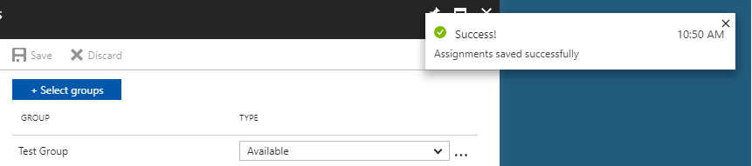

1. So, in this way you can add apps to Microsoft Intune through AppStore URL & assign it to the group.
2. Now, open **Company Portal app**, and you can see VLC Media Player is added in the Apps List.

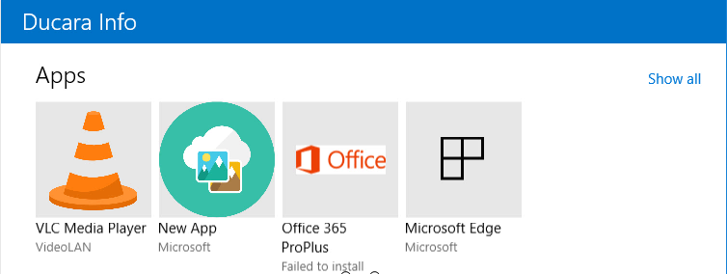

1. Open app and click **View in Windows Store**. It will open the AppStore URL in the Windows Store from where your employees can download and install in their machines.

